Additional File 1: Supplementary figures and table.

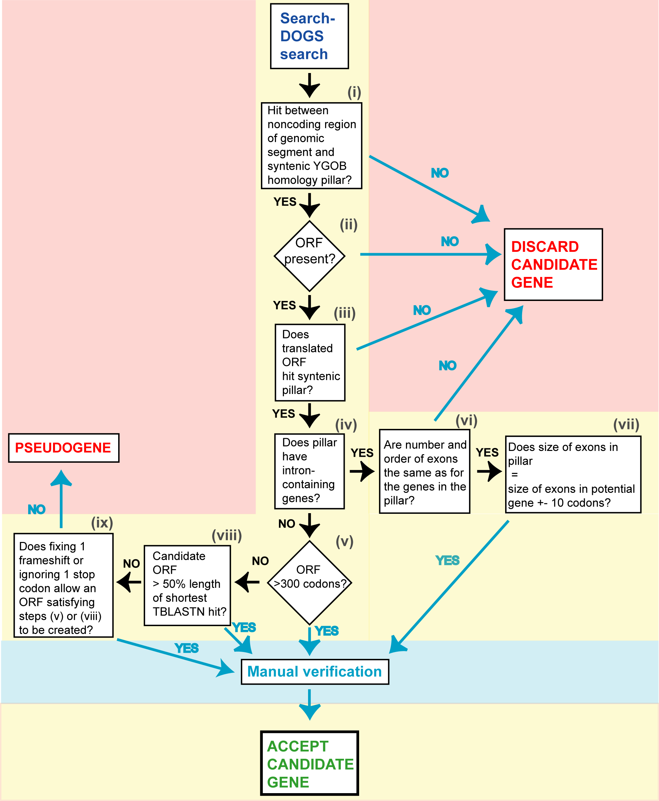

Figure S1: Flowchart illustrating the criteria that must be achieved for a SearchDOGS hit to be considered a bona fide gene. The automated steps are marked with roman numerals. All candidate genes that pass the automated steps are subjected to a manual examination before they are accepted.

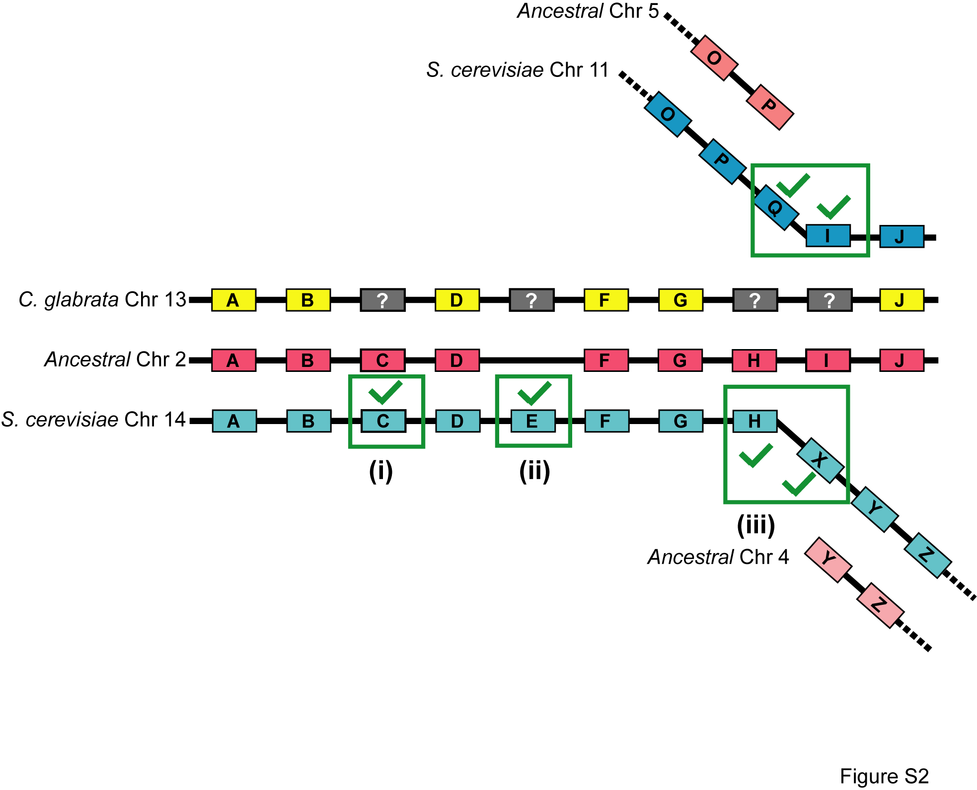

Figure S2: Cartoon illustrating the automated SearchDOGS method for establishing orthology between genomic segments. For ease of explanation, only two extant species are shown (S. cerevisiae in blue, and C. glabrata in yellow), as well as the Ancestral genome (pink; parts of Ancestral chromosomes 2, 4 and 5 are shown).

(i) Testing for a possible C. glabrata ortholog of gene C, which is included in the Ancestral genome. For the C. glabrata genomic fragment B-D, the two annotated genes have Ancestral orthologs (Anc_2.B and Anc_2.D) that are less than 10 ancestral genes apart. In this situation, we use the intergenic region between C. glabrata B and D as a BLASTX query against a database that contains the translations of all genes that map between Anc_2.B and Anc_2.D. Therefore S. cerevisiae gene C is included in this database (green tick and box).

(ii) Testing for a possible C. glabrata ortholog of gene E, which is not included in the Ancestral genome. For the C. glabrata genomic fragment D-F, the two annotated genes have orthologs in another species (S. cerevisiae) that are less than 10 genes apart. In this situation, we put each of the genes from that species (i.e., S. cerevisiae gene E) in the database against which the C. glabrata intergenic region will be searched using BLASTX.

(iii) Interspecies rearrangements. In this example, an interspecies rearrangement has occurred in S. cerevisiae relative to the Ancestor and C. glabrata, creating two new gene orders G-H-X-Y-Z and O-P-Q-I-J in S. cerevisiae. To search for possible unannotated genes in the interval between C. glabrata G and J, we define two orthologous S. cerevisiae genomic segments as follows. First, we consider the gene on the left end of the C. glabrata segment, Cgla G. We identify its S. cerevisiae ortholog from the same pillar (Scer G), and walk rightwards from this gene until we reach the point where synteny is lost (Scer Y; we know that synteny is lost because it is in a pillar with a different part of the ancestral genome, Anc_4.Y). We therefore put S. cerevisiae genes encountered on this walk (Scer H and X) into the database against which the C. glabrata G-J intergenic interval will be searched by BLASTX. Second, we similarly consider the gene on the right end of the C. glabrata segment, Cgla J, find its S. cerevisiae ortholog (Scer J) and walk leftwards in S. cerevisiae until synteny is known to be lost (at Scer P). We add the S. cerevisiae genes from this encountered on this walk (Scer I and Q) to the database. Thus the C. glabrata G-J intergenic region will be used as a BLASTX query against a database containing S. cerevisiae H, X, Q and I.

